To demonstrate SQL Injection vulnerabilities using DVWA and understand how improper input validation can expose sensitive database information.

Software Required
- Oracle VirtualBox
- Kali Linux
- Apache2
- MariaDB/MySQL
- PHP
- DVWA (Damn Vulnerable Web Application)
- Firefox Browser

Step 1: Start the Virtual Machine
- Open Oracle VirtualBox.
- Select Kali Linux.
- Click Start.
4. Login to Kali Linux.
Step 2: Open Terminal
Click the Terminal icon.

Step 3: Update the System
sudo apt update

Step 4: Install Apache
Check whether Apache is installed.
apache2 -v
If not installed:
sudo apt install apache2 -y
Start Apache:
sudo systemctl start apache2
Enable Apache:
sudo systemctl enable apache2
Verify:
sudo systemctl status apache2
You should see:
Active: active (running)

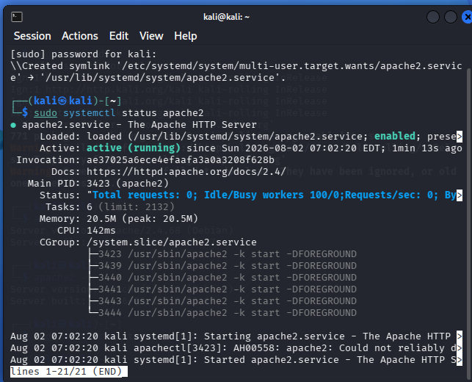
Step 5: Install MariaDB
sudo apt install mariadb-server -y
Start MariaDB:
sudo systemctl start mariadb
Enable MariaDB:
sudo systemctl enable mariadb
Verify:

sudo systemctl status mariadb
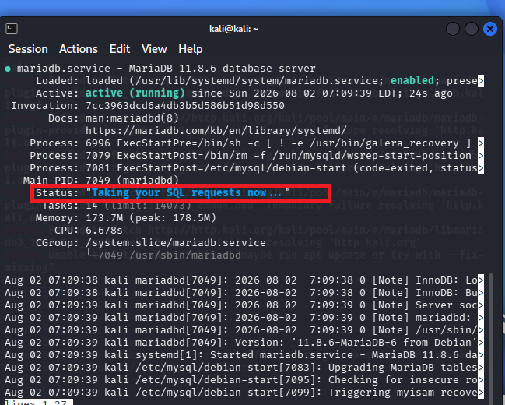
Step 6: Install PHP
sudo apt install php php-mysql libapache2-mod-php -y
Check PHP version:
php –v
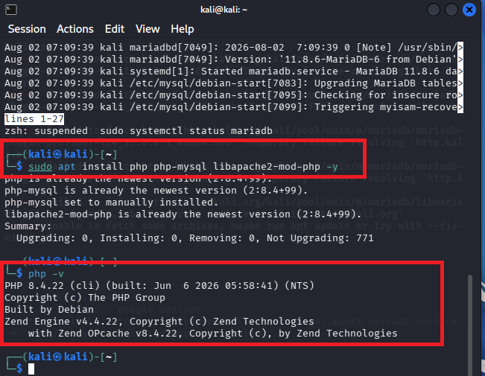

Step 7: Install Git
sudo apt install git -y

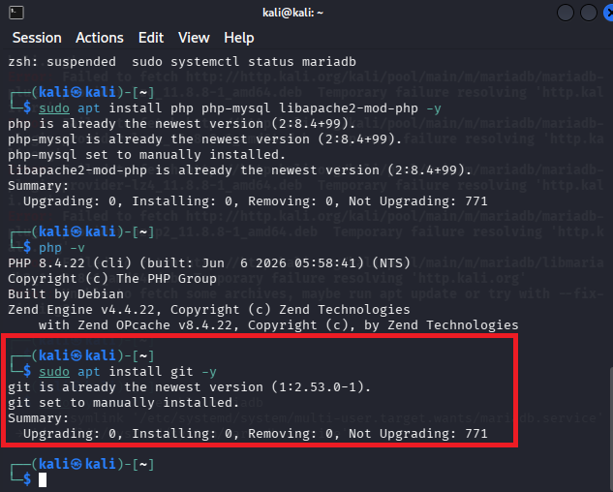
Step 8: Download DVWA

Move to the web server directory:

cd /var/www/html

Remove the default page (optional):

sudo rm index.html

Download DVWA: sudo git clone https://github.com/digininja/DVWA.git
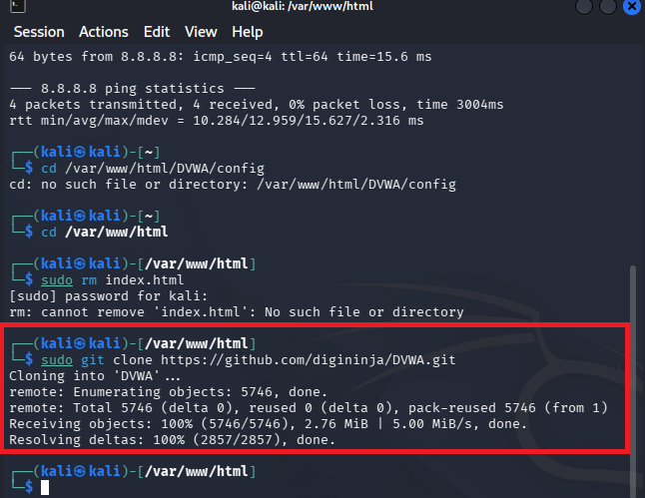
Step 9: Configure DVWA

Go to the configuration folder:

cd /var/www/html/DVWA/config

Copy the sample configuration:

sudo cp config.inc.php.dist config.inc.php

Step 10: Create the Database
Open MariaDB: sudo mysql
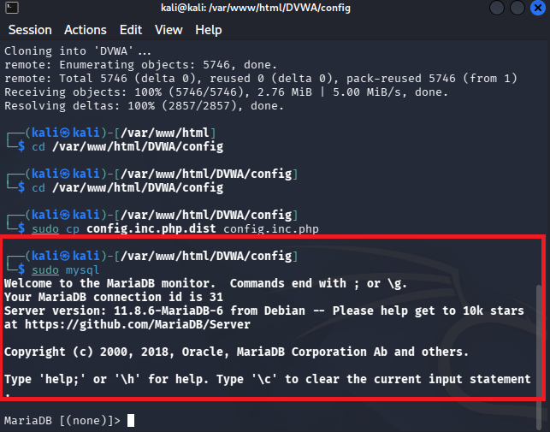
Create the database:
CREATE DATABASE dvwa;
Create a user:
CREATE USER 'dvwa'@'localhost' IDENTIFIED BY 'p@ssw0rd';
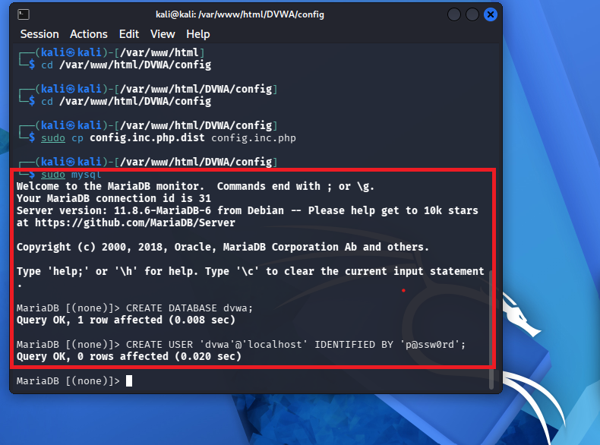
Grant permissions:
GRANT ALL PRIVILEGES ON dvwa.* TO 'dvwa'@'localhost';
Reload privileges:
FLUSH PRIVILEGES;
Exit: EXIT;
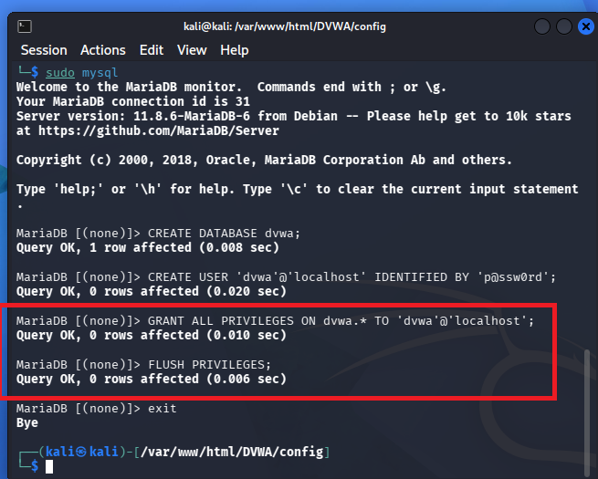

Step 11: Edit the Configuration File
Open:
sudo nano /var/www/html/DVWA/config/config.inc.php
Modify the database settings:
$_DVWA['db_server'] = '127.0.0.1';
$_DVWA['db_database'] = 'dvwa';
$_DVWA['db_user'] = 'dvwa';
$_DVWA['db_password'] = 'p@ssw0rd';
Save:
Ctrl + O
Press Enter.
Exit:
Ctrl + X

Step 12: Give Permissions
sudo chmod -R 777 /var/www/html/DVWA/hackable/uploads
sudo chmod -R 777 /var/www/html/DVWA/config

Step 13: Restart Apache
sudo systemctl restart apache2
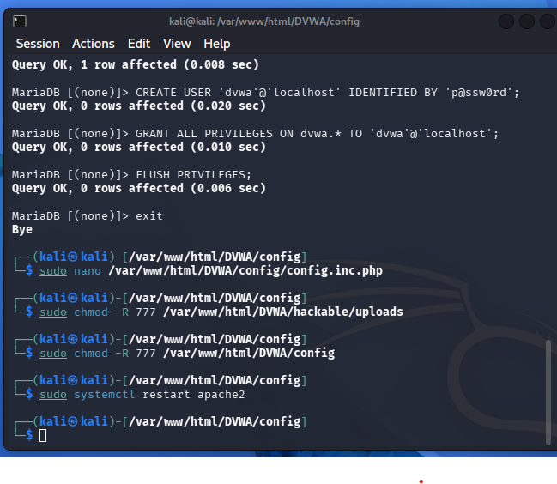

Step 14: Open DVWA
Open Firefox.
Visit:
http://localhost/DVWA
The DVWA setup page appears.
Click
Create / Reset Database
After the database is created, log in.

Step 15: Login
Username
admin
Password
password
Click Login.
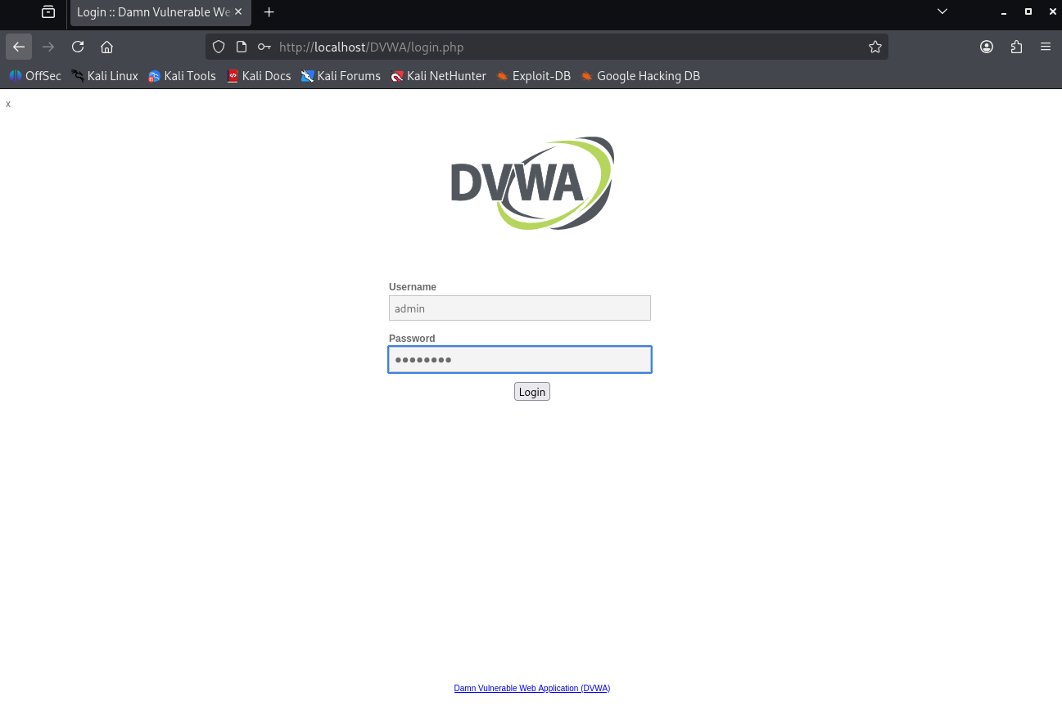

Step 16: Set Security Level
Click
DVWA Security
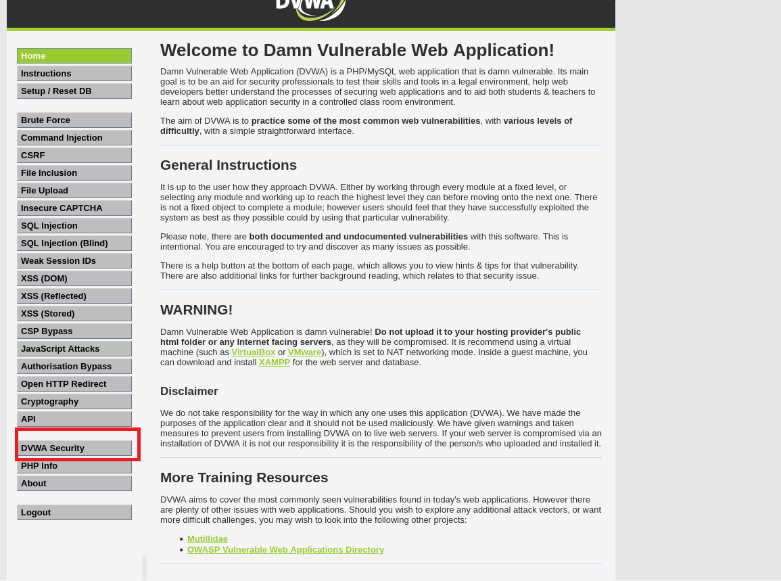
Select Low
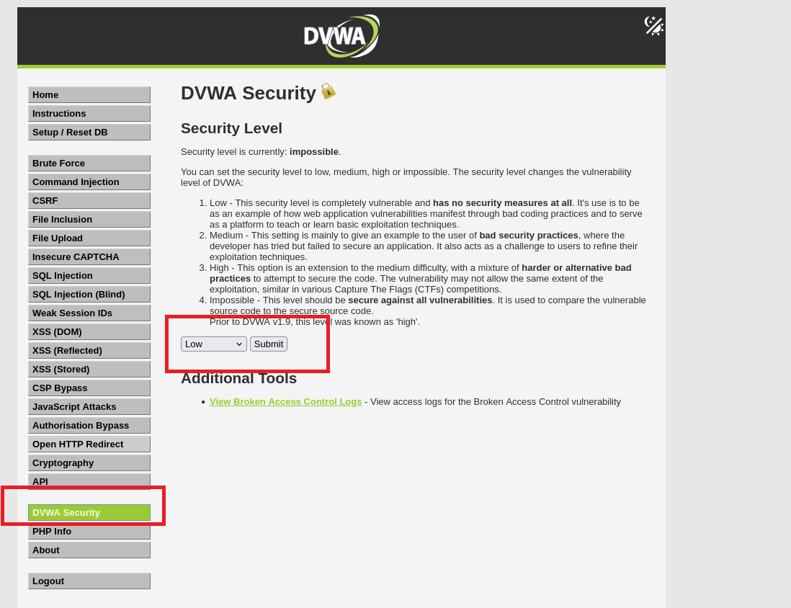
Click
Submit

Step 17: Open SQL Injection Module
From the left menu select
SQL Injection
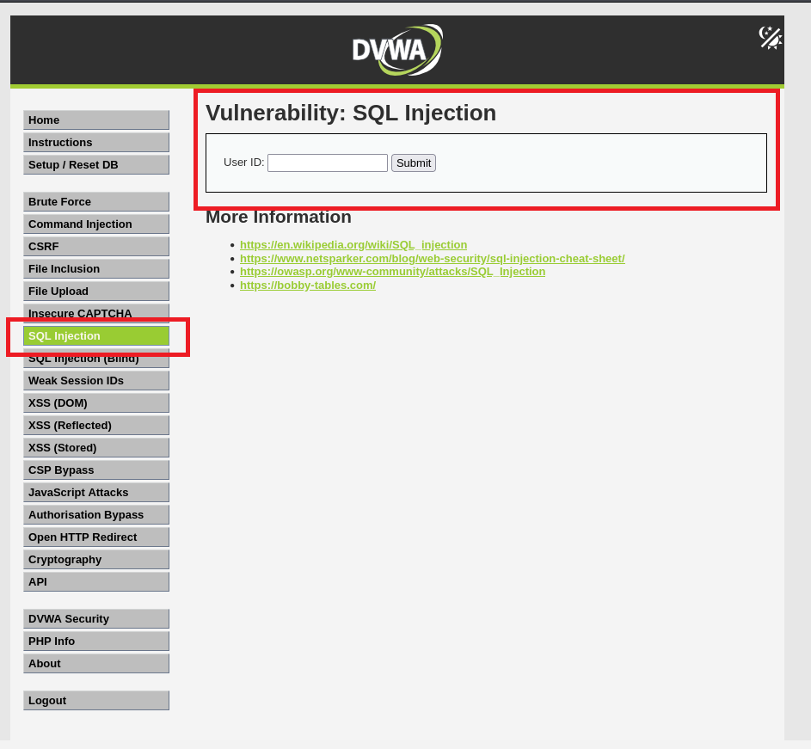
You will see:
User ID:
__________

[Submit]

Step 18: Test Normal Input
Enter
1
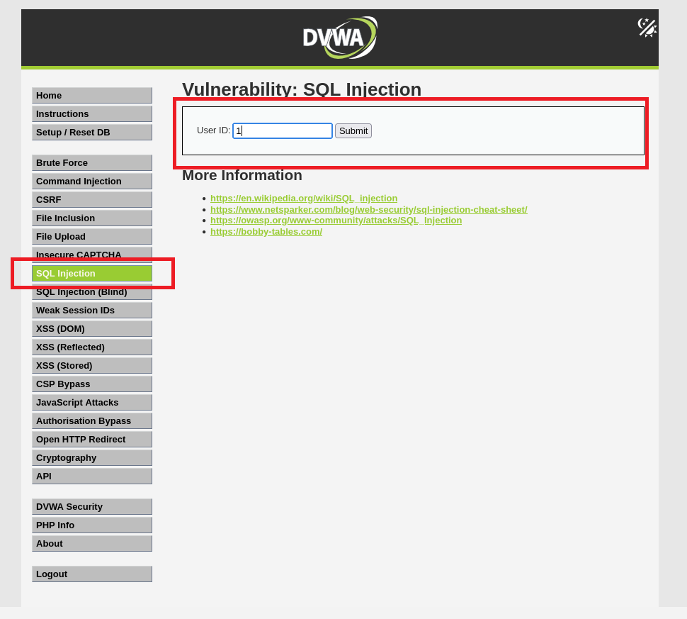
Click
Submit
The page displays details of User ID 1.
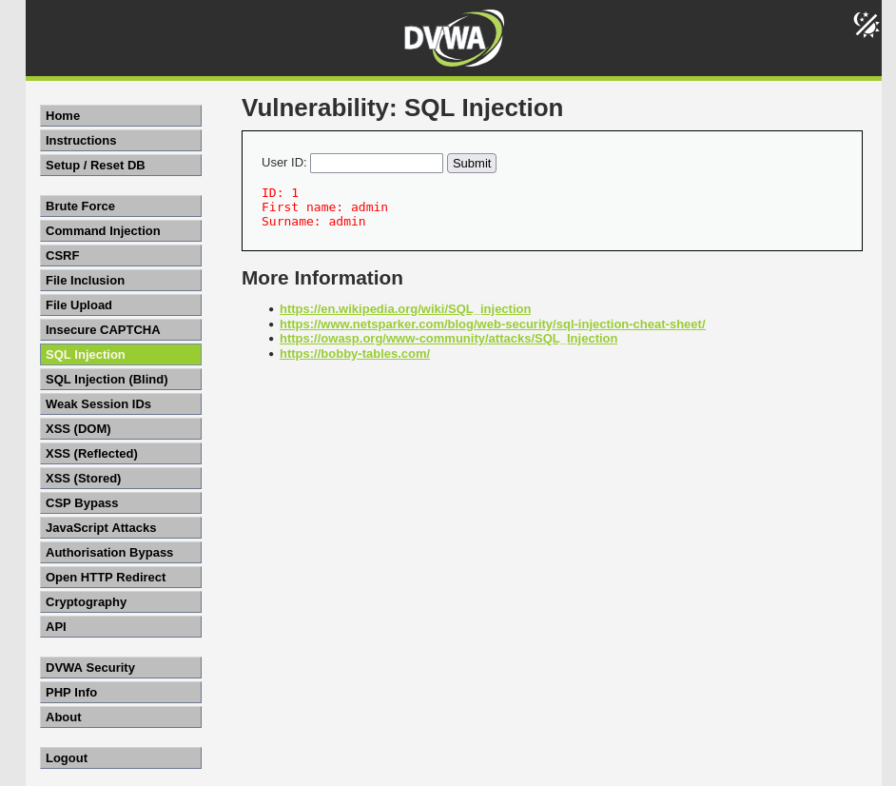

Step 19: Test for SQL Injection
Enter:
'
Click Submit.
If the application displays an SQL error or behaves unexpectedly, it suggests the input is not being handled safely. This demonstrates why applications should validate input and use parameterized queries.

Step 20: Observe the Results
Observe how different inputs affect the application's behavior.
Record:
- Returned user information
- Error messages (if any)
- Differences between valid and invalid input

Step 21: Understand Prevention
Discuss the following secure coding practices:
- Prepared (parameterized) statements
- Input validation
- Least-privilege database accounts
- Hiding detailed database error messages
- Regular security testing

Shut Down Apache and MariaDB
- Open a terminal and run:
- sudo systemctl stop apache2
- sudo systemctl stop mariadb
- Verify they have stopped:
- sudo systemctl status apache2
- sudo systemctl status mariadb

